Configuration of JavaFx for Java11+
Step 1:
First, we need to configure the system variables for java on Windows 10 or 11. We need to download the JDK of java here: Java Downloads | Oracle then we download the x64 installer for windows. After that we write on the windows search bar “variables de entorno del sistema”:
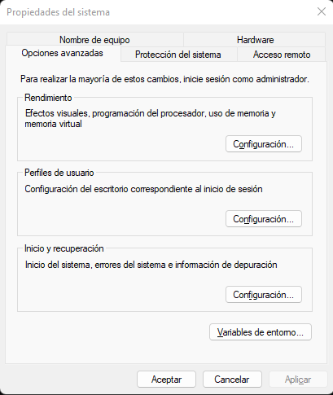
We select “variables de entorno”, here we should select on “nueva” and write:
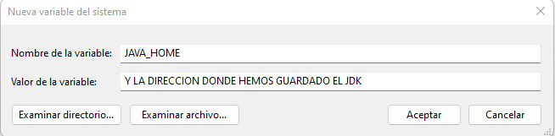
Once we have done this our computer will be able to identify java.
Step 2:
We need to download the jars of JavaFx from their official site: Gluon and JavaFX - Gluon (gluonhq.com) and save them on a known location, we will be needing them later.
Step 3:
Now we move to eclipse and we are going to configure the JavaFx. We search in the menu bar for Help->Eclipse Marketplace and we search for java Fx and we download it. Once we download this we have java fx but we will have errors and the project will not compile. We need to modify the JRE so eclipse knows where java Fx is.
Step 4:
We need to look on the menu bar for Window->Preferences->Java->BuildPath->UserLibraries.
We select on new and we are going to give it a name, preferably JavaFX and we add the JavaFX jars we download previously. We should have something like this:
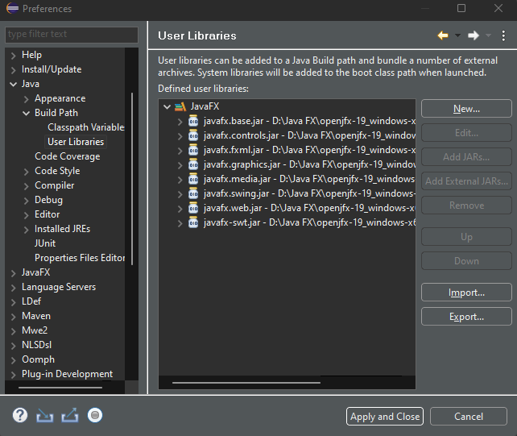
Now we are going to configure the JRE. On the same window we search for Installed JREs we are going to end on a view like this:
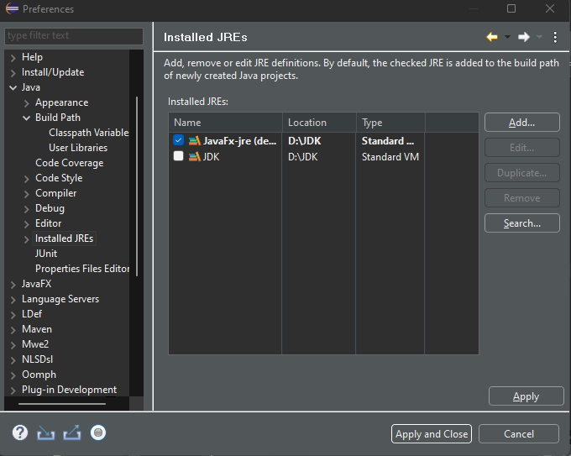
We need to click on the button add and we click on “standard VM”. On JRE home we need to search for the directory where the new version of the JDK has been installed. It should be on your hardrive C:/programarchives/java/”jdk version”. Next, we are going to add the java FX jars we download previously clicking on “Add external Jars”. This will make the program to appear with no errors but is not enough to compiler it. On the same window we search for “Default VM arguments” and we are going to write the following: “--module-path "D:\Java FX\openjfx-19_windows-x64_bin-sdk\javafx-sdk-19\lib" --add-modules javafx.controls,javafx.fxml”. The highlighted red text must be substituted by the path where your javaFx jars are stored on your computer. We click on finish. Something like this should appear:
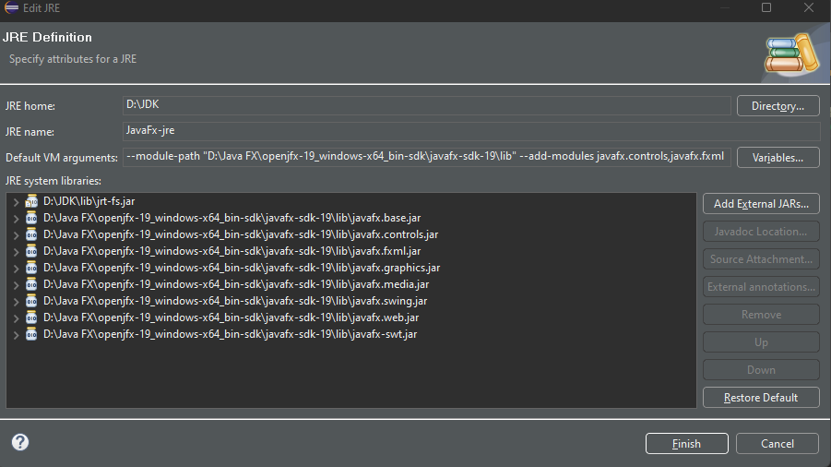
Step 5: (Probably optional):
If for some reason we cannot compile the program or we have some errors this is because our eclipse project is not working with the correct JRE so we need to tell him which one we are going to use. On the menu bar Window->Preferences->Java-Installed JREs We should check the box which identifies the new JRE we created as the predefined one.
